1. We said already, container is based on an image.
2. There are two ways to create an image.
   1. **Existing Image**: Source will be **Docker Hub** 🡺 **hub.docker.com**
      1. By a colleague or
      2. official pre-built image: Created, distributed and maintained by official team (like Node Team)
      3. an image shared by the community.
3. node image: It contains node installation.
4. 
5. 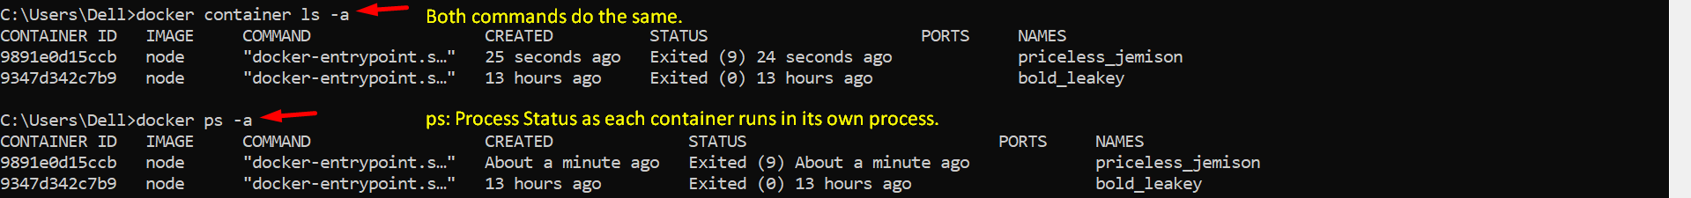
6. docker run -it node   
   This will just give you interactive shell where you can run node commands.   
   **NOTE**: if you don’t pass -it, the container will exit immediately.